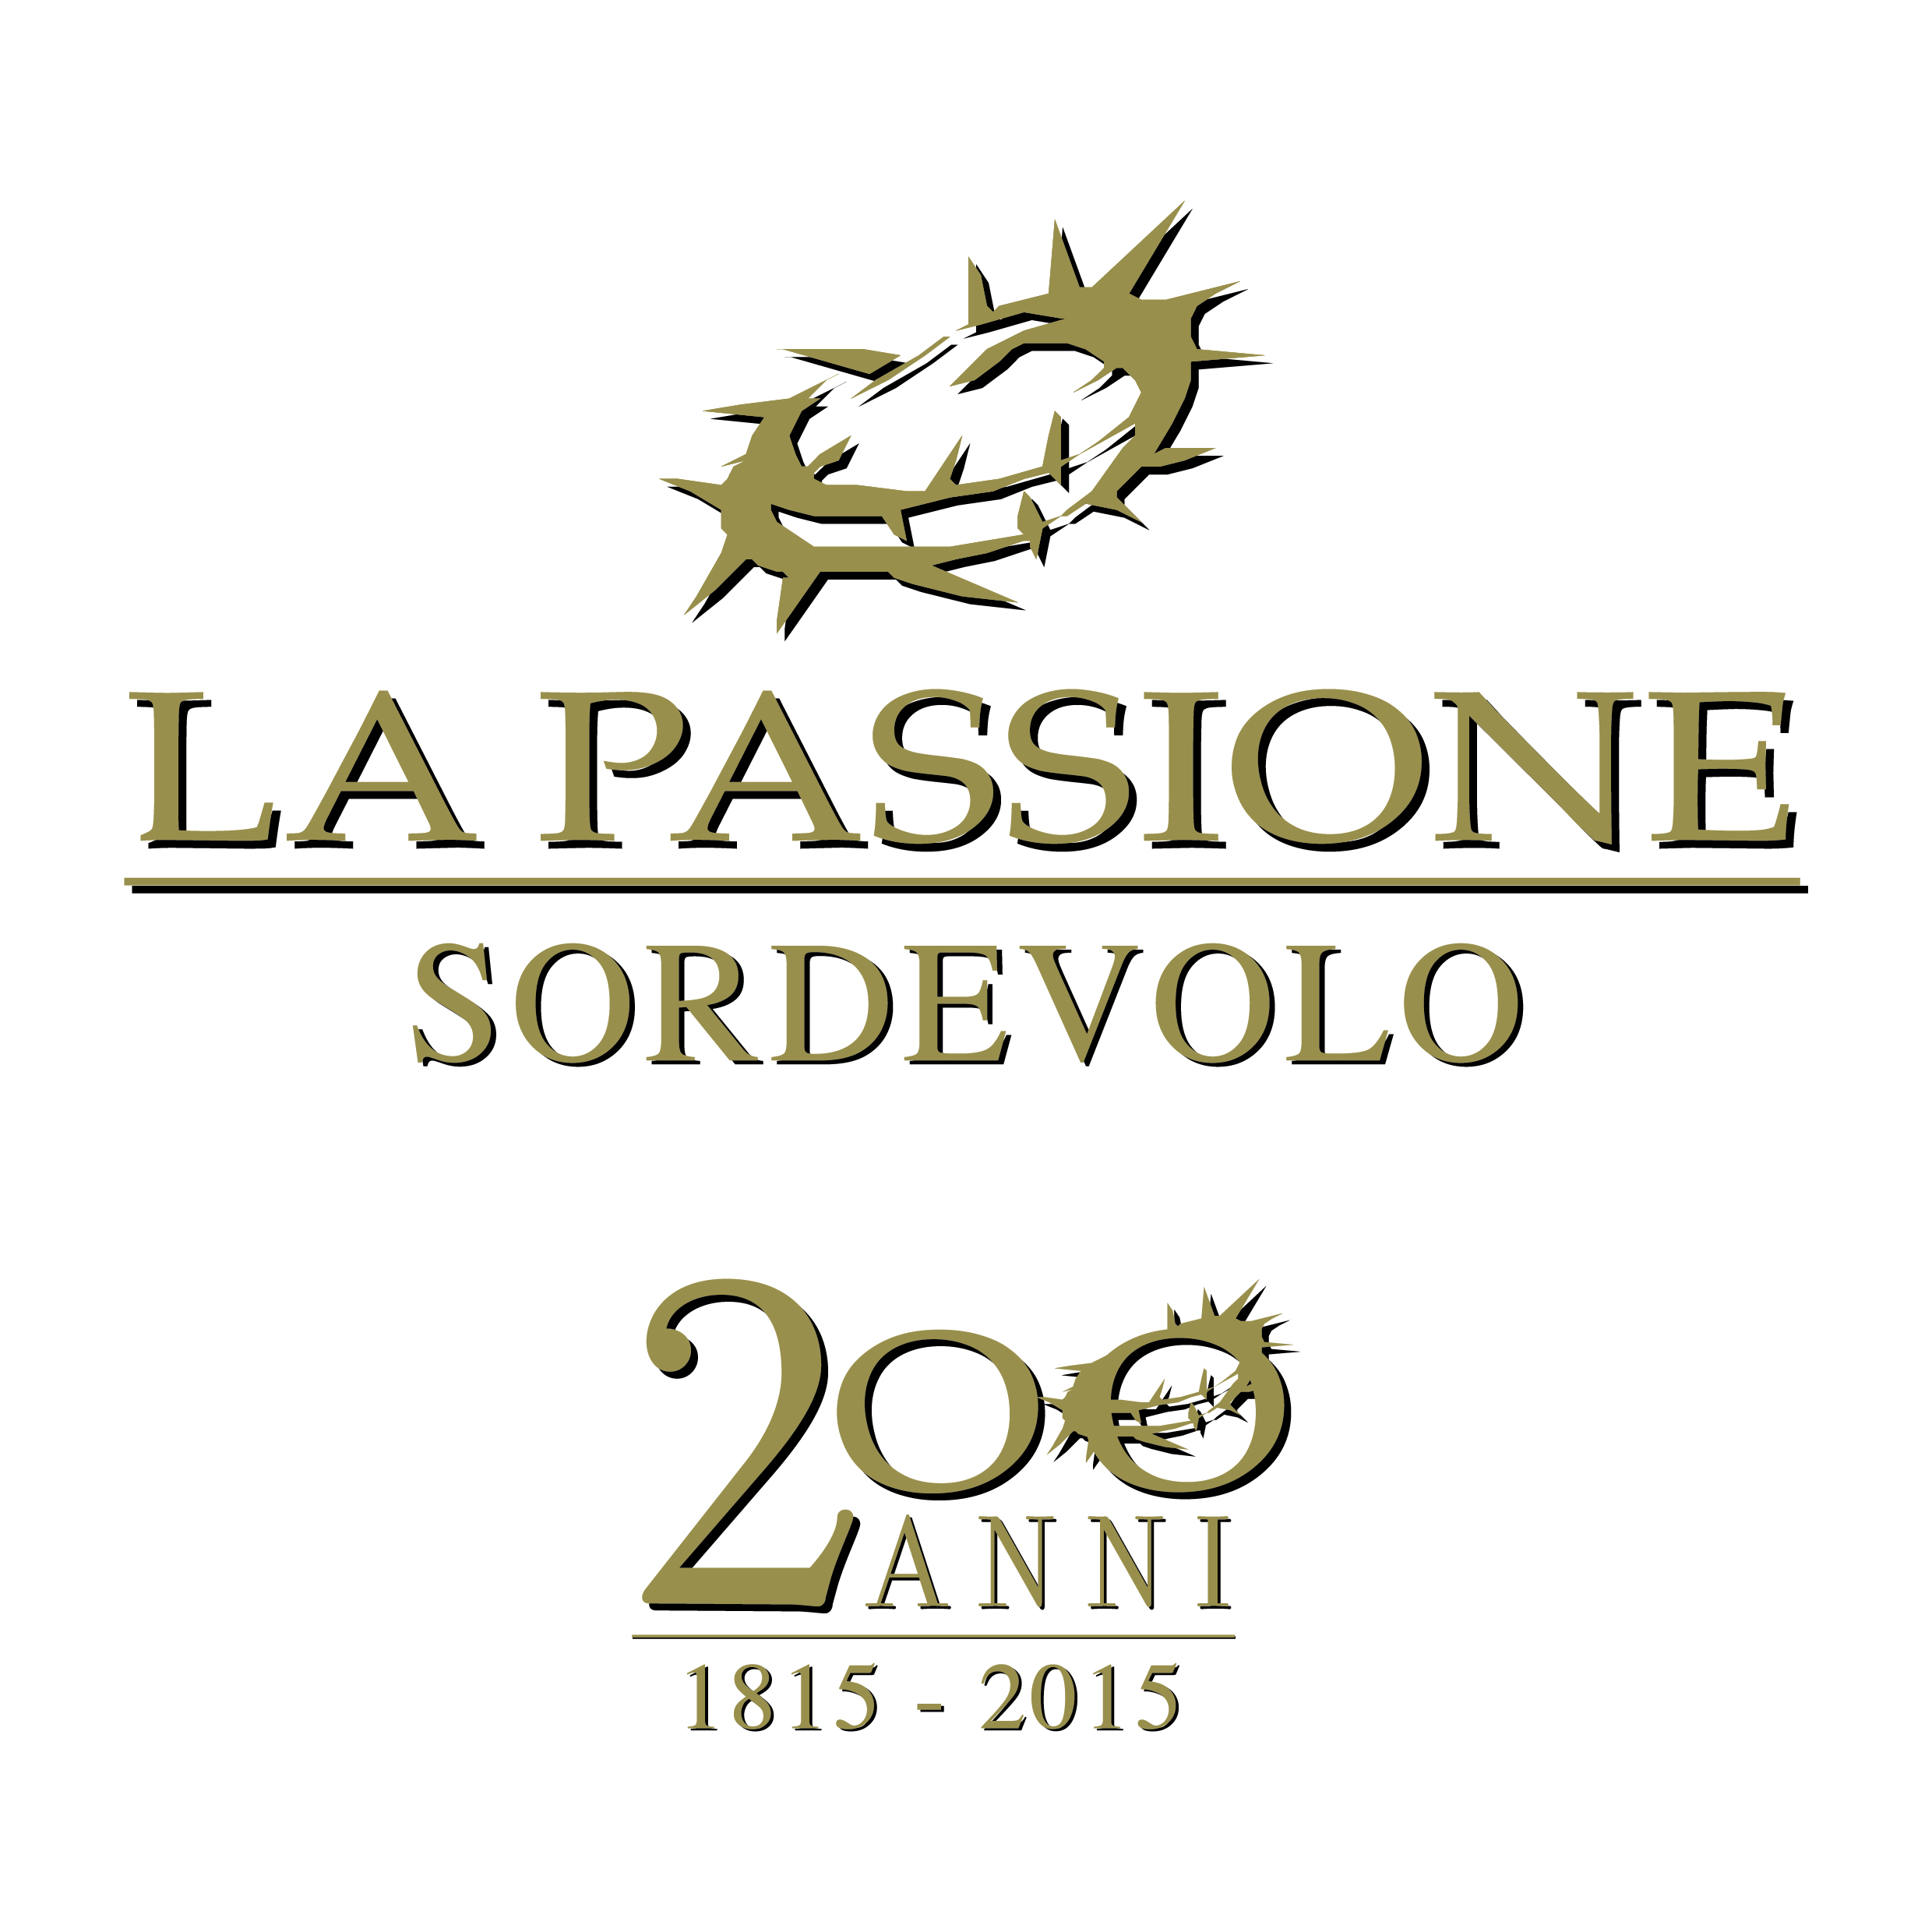

31st INTERNATIONAL CONGRESS
9-10-11-12 JULY 2015

SCHEDULE

THURSDAY, 9th JULY

From 2:00 p.m. welcome buffet at Alpini headquarters (Via De Valle) and rooms assignment
8:00 p.m. dinner with traditional cuisine of our region; your typical products, that you will kindly offer, will be well-accepted
Musical evening

FRIDAY, 10th JULY

9:00 a.m. meeting and departure for Oropa Sanctuary (guided tour)
12:30 p.m lunch at a typical restaurant of the Sanctuary
4:00 p.m. back to Sordevolo and visit of “Passion Museum” and amphitheatre Giovanni Paolo II
6:00 p.m. official welcome of delegations from the Mayor of Sordevolo at the City Hall
8:30 p.m. official dinner offered by Sordevolo City Hall
Musical evening
SATURDAY, 11th JULY

8:30 a.m. meeting at amphitheatre Giovanni Paolo II
9:00 a.m. delegates: 31st International Congress at the conference hall of
Città Studi (Biella)
partners: visit of Ricetto di Candelo (Medieval fortified village)
1:00 p.m. lunch at the conference hall of Città Studi (both delegates and partners)
3:00 p.m. back to Sordevolo
6:00 p.m. Holy Mass at the Parish Church of Sordevolo
8:00 p.m. dinner
9:30 p.m. Holy performance of the Passion Play of Sordevolo

SUNDAY, 12th JULY

9:00 a.m. Meeting with breakfast and farewells at amphitheatre Giovanni Paolo II

N.B. during the dinner on Thursday 9th, to celebrate with friendship and joy the pleasure to meet us again, the tasting of typical Europeans products, that each delegation would kindly offer, would be appreciated.

